1. **GCC (GNU Compiler Collection)**

* What is GCC?
* GNU is a free software operating system that is Unix-compatible. Its development started in 1983 by Richard Stallman. The GNU Project aims to create a complete Unix-like operating system that is composed entirely of free software.
* Working of GCC:

1. Writing a C/C++ Program:

* Consider the following program as an example:

#include <stdio.h>

int main() {

printf(“Hello, GNU World!\n)

return 0;

}

* Now I am compiling this program with the help of MinGW Installer, which is a tool of GNU.

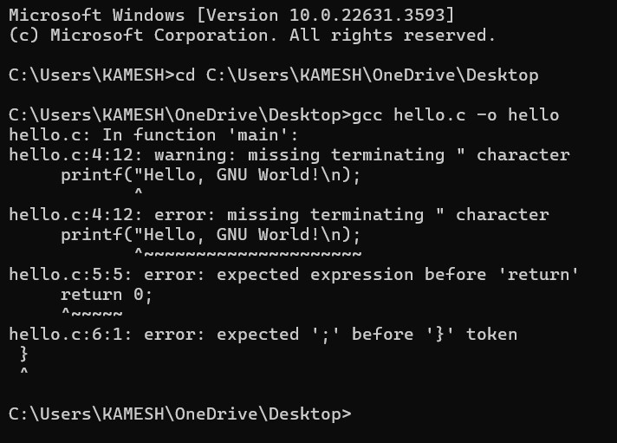

* As we can note the program misses an ‘ ; ’ . Which is indicated as error.
* This way the error is reported in an GCC Compiler.
* When Running the program, the program after fixing the error, the result obtained is –

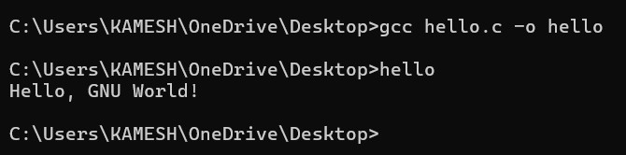

1. Documentation Link:

<https://www.gnu.org/gnu/thegnuproject.en.html>

**VISUAL C++**

* What is Visual C++?
* Visual C++ is an integrated development environment (IDE) from Microsoft for C, C++, and C++/CLI programming languages. It is part of the Visual Studio suite of tools and provides comprehensive facilities for software development.
* Working of Visual C++:
  + - 1. Writing a C/C++ Program:
* Consider the Following Program:

#include <stdio.h>

int main() {

printf("Hello, Visual Studio Code!\n")

return 0;

}

* Now I am Compiling this Program in visual studio code where I have an extension for C/C++ By Microsoft.

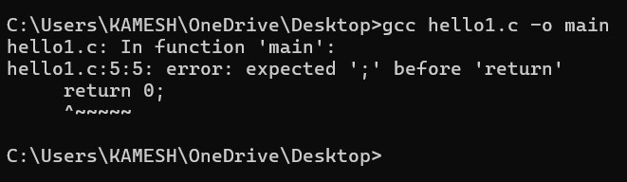

* The Error Noted Here includes an error of missing ‘;’ which is indicated as an compiler error.
* When the program Is compiled after fixing the error the output is-

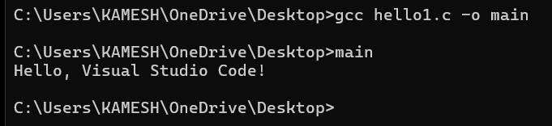

* + - 1. CODE HIGHLIGHTING:

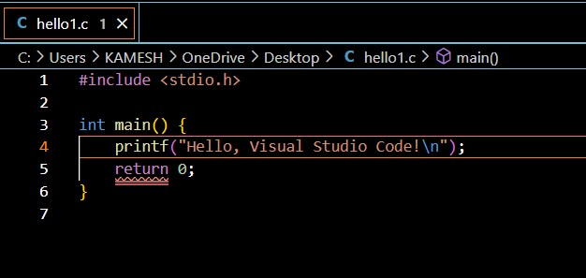

* + - 1. Documentation Link:

1. <https://code.visualstudio.com/docs>.
2. <https://code.visualstudio.com/docs/languages/cpp.>
3. <https://code.visualstudio.com/docs/cpp/config-mingw>.